**INTI International College Penang**

**School of Computing 3+0 Bachelor of Science (Hons) in Computer Science, in collaboration with Coventry University, UK 3+0 Bachelor of Science (Hons) in Computing, in collaboration with Coventry University, UK**

# **Coursework Cover Sheet**

**Section A - To be completed by the student.**

| Full Name: Rachel Ng Ker Xin, Stanley, Ng Yu Ze | |
| --- | --- |
| CU Student ID Number: | |
| Semester: 6 | |
| Lecturer: Kavitha Thamadharan kavitha.thamadharan@newinti.edu.my | |
| Module Code and Title: 5010CEM Enterprise Project | |
| Assignment No. / Title:  Group Report & Viva | % of Module Mark: 75/100 |
| Hand out date: 21st April 2025 | Due date: 1st July 2025 |
| Penalties: No late work will be accepted. If you are unable to submit coursework on time due to extenuating circumstances you may be eligible for an extension. Please consult the lecturer. | |
| Declaration: I the undersigned confirm that I have read and agree to abide by the University regulations on plagiarism and cheating and Faculty coursework policies and procedures. I confirm that this piece of work is my own. I consent to appropriate storage of our work for plagiarism checking.    Signature(s): ----Rachel---------------------------------- | |

**Section B - To be completed by the module leader.**

Intended learning outcomes assessed by this work:

1. Demonstrate an ability to work both individually and within a team to deadlines, exercising personal responsibility.

2. Show critical understanding and insight into the requirements of industrially driven software development work.

3. Integrate learning on prior and concurrent modules (as relevant) and show industrial relevance and application.

4. Scope, design, develop and critically evaluate a piece of large-scale software as a member of a team implementing Agile methodology.

5. Demonstrate professional-level skills in time management, problem analysis, and effective communication in speech and writing to specialist and non-specialist audiences.

| 6. Demonstrate ability to identify, interpret and critically apply professional standards as documented in professional codes of conduct of computing e.g. BCS and evaluate results in light of these. | | |
| --- | --- | --- |
| **Marking scheme** | **Max** | **Marks Awarded** |
| Task 1: Development of the Project & Group Viva | 50 |  |
| Task 2: Group Report | 50 |  |
| **Total** | 100 |  |
| Lecturer’s Feedback: | | |
| Internal Moderator’s Feedback: | | |

**Group Task:**

You are required to work in groups and develop a prototype based on the chosen topic below which requires skills and knowledge presented in the other modules studied in the semester. **5008CEM Programming for Developers**

All submissions will be checked against each other and on the internet for possible plagiarism.

**Task 1: Development of the Project & Group Viva (50%)**

Enterprise project modules often focus on creating solutions that enhance business processes, improve efficiency, and drive innovation. An enterprise system requires meeting certain requirements to ensure it effectively supports the organization’s operations, management, and decision-making processes.

**Requirements:**

1. The final prototype must be a fully functional website that incorporates the minimum required functionalities as outlined in section 6 below.

2. PHP programming language should be used to develop the website.

3. Students are free to use any web development framework that is compatible.

4. The use of pre-designed templates for user interface (UI) design, such as those offered by platforms like Wix.com and other analogous technologies, should be avoided.

5. Every user must register and log in to the system.

6. The final prototype **MUST HAVE** the following features:

(a) Able to create, edit and delete list of products/services

(b) Able to manage and process order

(c) Able to perform inventory control

7. You may add any other features/functions such as:

| **Basic** | The must-have functionalities listed above are included and are fully functional. |
| --- | --- |
| **Intermediate** | On top of basic requirements, the users should be able to manage profiles, manage promotions, track order and order status updates. |
| **Advance** | On top of the basic and intermediate requirements, the user should be able to generate sales reports, inventory reports and revenue tracking in the system. |

**Group Viva:**

You should submit a single PPT file with a filename in the following format:

Name_INTIID_SubjectCode_AssignmentName

e.g.: KavithaThamadharan_P2012345_5010CEM_Presentation.ppt

Viva will be conducted in **Week 14 & 15 of APRIL 2025 Session** in class. The presentation duration is 1 hour including questions & answers session with the examiners.

Viva component including as follows:

- Presentation slide

- System demo

**Task 2: Group Report (50%)**

You are expected to develop documentation that covers the following areas:

**Section 1: Critical evaluation of agile techniques applied to manage the group project**

• Overview of Agile Methodology: Brief description of Agile principles and practices.

• Selection of Agile Framework: Discussion on why a specific Agile framework (e.g., Scrum, Kanban) was chosen.

• Team Dynamics and Collaboration: Evaluation of how Agile practices affected team collaboration and communication.

• Iteration Planning and Execution: Analysis of how iteration planning was conducted and how effectively iterations were executed.

• Performance Metrics: Evaluation of metrics used to measure Agile success (e.g., velocity, burn-down charts).

**Section 2: Critical review of scoping, design, development and testing of the software product as a group to meet business requirements**

• Scope Definition: Analysis of how project scope was defined and managed.

• Requirements Gathering: Review of methods used to gather and document project requirements.

• Design Process: Evaluation of the design approach, including UI/UX design, and design documentation.

• Development Practices: Assessment of development practices, including coding standards, version control, and integration.

• Testing Strategy: Review of testing methods employed (e.g., unit testing, integration testing).

• Changes and Iterations: Analysis of how scope and design changes were managed and their impact on the project.

**Section 3: Evaluation of current technologies applied to the software development** • Technology Stack: Overview of the technologies and tools used in the project (e.g., programming languages, frameworks, databases).

• Technology Selection Rationale: Justification for choosing specific technologies.

• Integration of Technologies: Analysis of how different technologies were integrated into the project.

**Section 4: Evaluation of software development against professional standards.**

• Compliance with Industry Standards: Analysis of adherence to industry standards (e.g., ISO, IEEE).

• Code Quality and Maintainability: Evaluation of code quality, including readability, maintainability, and adherence to coding standards.

• Ethical and Legal Considerations: Assessment of ethical and legal aspects, including data protection and intellectual property.

**Guidelines for Documentation:**

1. Font Name and Size: Use Times New Roman with a 12pt font size for the entire document.

2. Line Spacing: Set the line spacing to 1.5 throughout the document.

3. Alignment: Ensure the text is justified so that both the left and right margins are aligned.

4. Page Numbers: Include page numbers on every page.

5. Word Count: The total word count must not exceed 5000 words.

6. Referencing: Include a full citation for each source in the reference list, following the Coventry University Harvard referencing style guidelines.

7. Submission Requirements:

a. The assignment must be submitted ONLINE only through the designated platform (Canvas).

b. Before final submission, the report must be checked for plagiarism using Turnitin.

c. If the plagiarism percentage exceeds 15%, you are required to provide a justification along with valid reasons for the higher similarity index.

d. You should submit a single PDF file with a filename in the following format:

FullName_INTIID_SubjectCode_AssignmentName

e. g.: KavithaThamadharan_P2012345_5010CEM_Report.pdf

**Marking Rubric:**

**Task 1: Development of the Project & Group Viva (50%)**

| **Criteria** | **Distinction (70 – 100)** | **Merit (50 – 69)** | **Pass (40- 49)** | **Fail (0 – 39)** |
| --- | --- | --- | --- | --- |
| **System Design (10%)** | Clear and efficient  design, welldocumented, supports integration. Well-structured schema, supports all functionalities, ensures data  integrity. Intuitive, user-friendly, aesthetically pleasing, consistent navigation | Basic design lacks some details, moderate integration. Basic schema supports most functionalities, some data integrity issues. Functional but basic design, some usability issues, inconsistent in places | Incomplete or unclear design, poor integration. Poorly structured schema lacks support for key functionalities, significant data integrity issues. Difficult to use, confusing navigation, poor aesthetics and usability. | The system design is either incomplete or lacks clarity. The design fails to demonstrate effective integration between modules. The schema may be  overly simplistic, or overly complex without a purpose. The system is challenging for users to interact with, due to a non-intuitive interface, confusing workflows, or complex operations that do not align with user expectations or needs. |
| **Implementation (10%)** | All required functionalities implemented correctly and efficiently. Highquality code, follows  standards, wellcommented, modular. Seamless integration, smooth data flow, efficient interaction between modules. | Most functionalities implemented, some minor issues. Basic code quality follows some standards, moderate commenting, some modularity. Basic integration, some data flow issues, occasional module interaction problems. | Key functionalities missing or  implemented incorrectly. Poor code quality, inconsistent standards, lack of comments, monolithic code. Poor integration, significant data flow issues, modules do  not interact effectively. | Critical features of the system are either absent or incorrectly implemented, leading to significant gaps in the system’s performance. The system fails to meet the core objectives or requirements outlined in the project brief. The system components do not integrate effectively. |
| **Testing**  **(10%)** | Comprehensive plan covers all testing levels, detailed test cases. Thorough execution, all functionalities tested, issues documented and fixed. | Basic plan covers most testing levels, some detailed test cases. Moderate execution, most  functionalities tested, some issues documented and fixed. | Incomplete plan lacks coverage of key testing levels, minimal test cases. Poor execution, key functionalities not tested, issues not documented or fixed. | The testing plan is insufficient, missing critical levels such as unit, integration, system, or acceptance testing. Key functionalities are either not tested or tested inadequately, resulting in undetected bugs or issues. |
| **Presentation of**  **Final Group Work (20%)** | Clear and organized presentation of the final group project. Effective demonstration of the developed system | Some relevant information is provided;  understanding of the topic is adequate but lacks depth. | Content is unclear, irrelevant, or  superficial; demonstrates a lack of understanding of the topic. | The presentation fails to convey the key aspects of the final group project effectively. The information |
|  | functionalities, showing how they meet business requirements. Confident, engaging delivery; maintains eye contact, uses clear voice and appropriate gestures. | Somewhat  organized; structure is present but may  lack clarity or coherence in transitions. Delivery is somewhat engaging; occasional lack of eye contact or unclear voice. | Disorganized; lacks clear structure and coherence; transitions are abrupt or confusing. Delivery is hesitant, lacks engagement; poor eye contact, unclear voice, or distracting gestures. | presented is either not relevant to the project or lacks depth, showing a poor understanding of the topic and its significance. The presenter avoids eye contact and speaks  in a manner that is difficult to understand. |

**Task 2: Group Report (50%)**

| **Criteria** | **Distinction (70 – 100)** | **Merit (50 – 69)** | **Pass (40- 49)** | **Fail (0 – 39)** |
| --- | --- | --- | --- | --- |
| **Critical Evaluation of Agile**  **Techniques**  **Applied to Manage the Group Project**  **(15%)** | Thorough evaluation of agile techniques, covers all aspects of project management, includes relevant examples. Clear explanation of how agile techniques were applied, specific to the project context. | Basic evaluation covers most aspects, some relevant examples. General explanation of agile application, somewhat relevant to the project. | Incomplete evaluation lacks coverage of key aspects, minimal or no examples. Vague  or unclear explanation, not specific to the project. | Key aspects of agile methodologies are not addressed or are superficially covered. The explanation of how agile techniques were applied is vague, unclear, or poorly articulated. The connection between agile practices and their application to the project is not welldefined, making it difficult to  understand how these techniques contributed to project management and outcomes. |
| **Critical Review of**  **Scoping, Design,**  **Development, and Testing of the**  **Software Product (15%)** | Comprehensive review of design phase, clear and well-structured design choices. Thorough review of testing phase, comprehensive test coverage, documented results | Basic review, some design choices explained, moderate structure. Basic review, moderate test coverage, some documented results | Incomplete review, unclear or poorly structured design choices. Incomplete review, minimal test coverage, lack of documented results | Design decisions are not well-articulated  or logically organized. The testing phase lacks comprehensive coverage, with only a few tests conducted or important test scenarios omitted. |
| **Evaluation of Current**  **Technologies**  **Applied to the Software**  **Development**  **(10%)** | In-depth evaluation of current technologies used relevance to project needs. Identification of innovative technologies or approaches,  justification for their use | Basic evaluation, some relevant technologies discussed. Some identification of innovative technologies, partial justification | Incomplete or irrelevant evaluation lacks discussion of key technologies. No identification of innovative technologies, no  justification | There is no attempt to explore or suggest advanced or alternative solutions. The evaluation lacks reasoning for why certain technologies are chosen or how they align with project requirements and objectives. |
| **Evaluation of the**  **Software**  **Development Against**  **Professional**  **Standards**  **(10%)** | Detailed identification of relevant professional standards, welldocumented. Clear evaluation of how standards were applied in the  project, specific examples | Basic identification,  some documentation. General evaluation, some application examples | Incomplete identification, poorly documented. Vague or unclear evaluation, minimal or no examples | Relevant professional standards are either not identified or inadequately covered. The documentation is lacking or fails to address the importance of these standards in the context of the project. |

# **Table of Contents**

**Coursework Cover Sheet 1**

**Table of Contents 10**

**Section 1: Critical evaluation of agile techniques applied to manage the group project 11**

1.1 Agile Methodology Overview 11

1.2 Agile Framework Selection 12

1.3 Team Dynamics & Collaboration 14

1.4 Iteration Planning and Execution 16

1.5 Performance Metrics 17

1.6 chapter summary 18

**Section 3: Evaluation of current technologies applied to the software development 19**

3.1 Technology Stack 19

3.2 Technology Selection Rationale 20

3.3 Integration of Technologies 23

**References 25**

# Section 1: Critical evaluation of agile techniques applied to manage the group project

# 1.1 Agile Methodology Overview

Based on the research, Agile Methodology is an organising system for arranging the projects that separates the work into numerous and flexible periods known as sprints. A method that is iterative is the Agile Methodology. The groups can review the achievements after the end of sprints to illustrate what it has done differently in order to change the plan for the following sprints (Sarah Laoyan 2025).

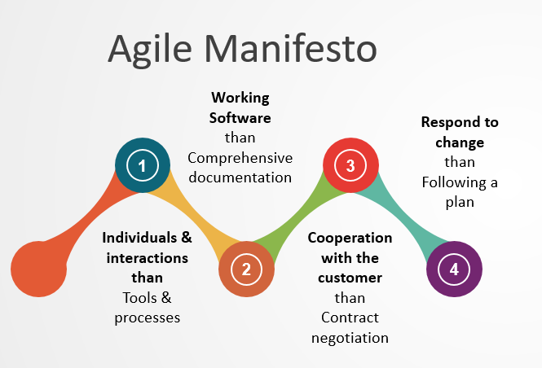

Figure 1.0 Agile Manifesto principles

Based on figure 1.0, the four Agile Manifesto for Agile Software Development principles are individuals and interactions than tools and processes, working software than comprehensive documentations, cooperation with the customer than contract negotiation and responding to change rather than following a plan (Beck et al., 2001).

Due to its clear sprint processes, different contributions such as scrum masters, product owners, development teams and the importance of sprint reviews, the group wished to start developing a scrum which is an accepted Agile methodologies. Scrum was chosen because it provides an educational duration of a functional system and concentrates on frequent outcomes that meet the objectives for the development of the TeeZone project. Based on the research, scrum also illustrates the essential of collaboration, communication and work as a group to fulfill the overall objectives. Moreover, the group will respond face to face immediately for the changes in requirements, comments and challenges (Design Gurus Team, 2025).

# 1.2 Agile Framework Selection

The Scrum Framework which was selected by the group can support collaborations, continuous value delivery for both individuals and groups. Scrum is an Agile Framework that provides groups and individuals that it fits into the processes by applying the best practices to fulfill the requirements. The Scrum team consists of Scrum master, product owner and developers ([Scrum.org](http://scrum.org), 2025).

Figure 1.1 Scrum Master 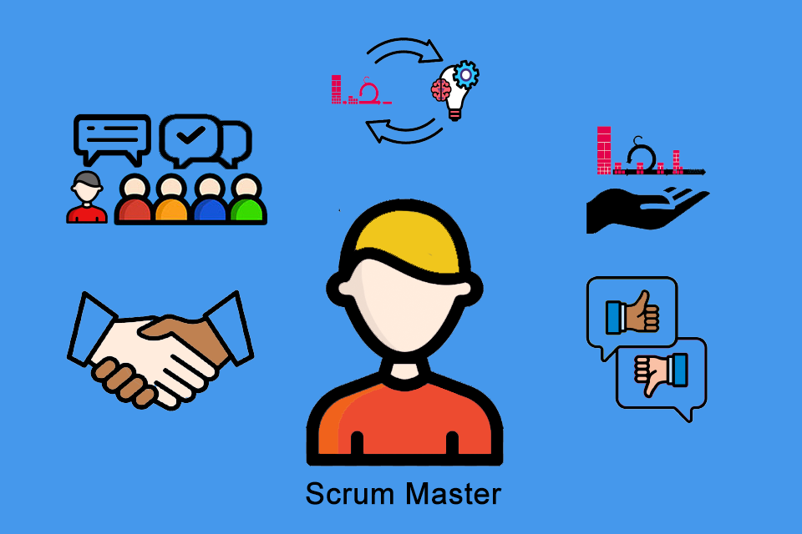

Scrum Master is a lightweight agile framework that consists of time-boxed frames called sprints. According to Scrum Guide, It serves as servant leaders and coaches to the group (Atlassian 2025). For the TeeZone project, YuZe will contribute as a Scrum master. Among his duties, YuZe will develop and oversee scrum ceremonies like stand-up meetings, sprint reviews, sprint planning and retrospectives. Moreover, YuZe also worked as an Agile coach that instructed the team on well practices and helped the team to comply with the principles of scrum such as honesty, investigation and freedom of movement. Furthermore, YuZe was helpful in identifying and removing obstacles that would delay the development like repairing technical issues and communicating with third parties where it is necessary.

Figure 1.2 Product Owner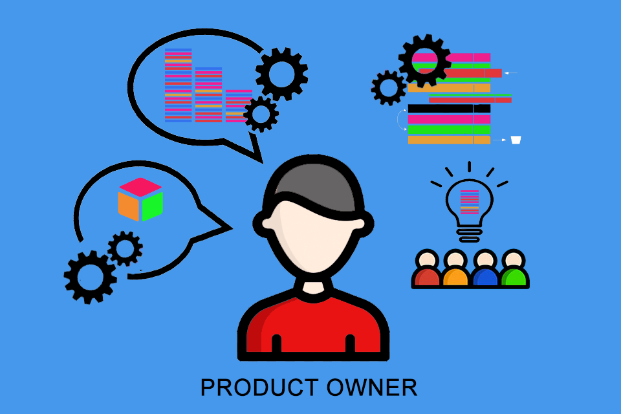

A product owner serves as a single source of information for multiple teams throughout the organization (Diane Hoffman 2024). In order to keep every organization modified on TeeZone project’s development, the group will collaborate closely with each other. In this TeeZone project, the product owner role is contributed by Rachel. The duties were to describe and communicate the product vision which is implementing an efficient and user-friendly online platform for selling college T-shirts at INTI International College Penang. Besides that, Rachel has received the requirements from the users like college marketing company, lecturers and students. It converted into clear and helpful user stories. Moreover, Rachel has selected and monitored the product backlog to ensure that every sprint has addressed the most significant and essential products. Additionally, Rachel has the opportunity to accept and reject finalized work to ensure that each product delivered has to be agreed with the user necessities and regulations.

Figure 1.3 Scrum Development Team

The participants of the Scrum Team are responsible for creating any components of beneficial steps per sprints are referred to developers (Ken Schwaber & Jeff Sutherland 2020). For the TeeZone project, Stanley will contribute to the role of developer. Developing the website technical functionality which are connecting the features of the database, coding the user interface (UI) and making sure that the system performance and usability was a major responsibility. In order to make sure that the development attempts fulfill the users requirements, Stanley partnered with the product owner to fully understand the user stories and requirements of the product.

# 1.3 Team Dynamics & Collaboration

For the duration of this project, the Agile Methodologies are necessary for encouraging positive team collaborations. The group manages to maintain collaboration that provides freedom and problem-solving with hybrid methods that are mixed with face to face meetings and social media.

Figure 1.4 Whatsapp Group for group discussion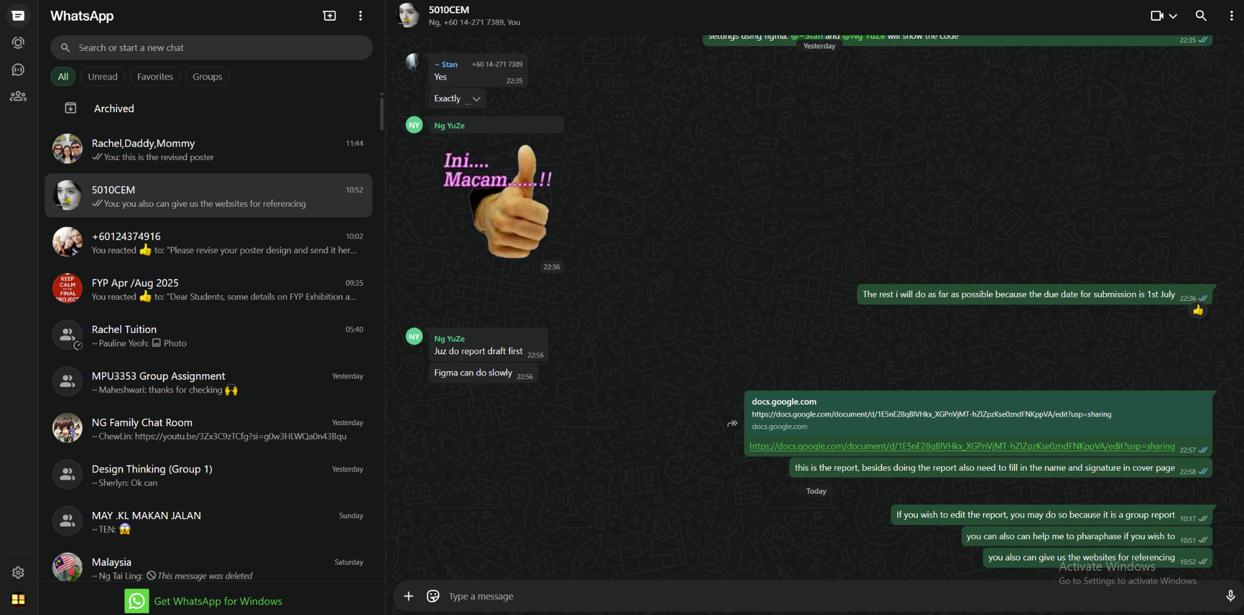

The implementation of Agile methods significantly enhances teamwork and collaboration. Due to the time issues and the college life limitations, the group will highly communicate through WhatsApp. Quick coordination, real-time updates and ongoing conversations of sprint were made possible through WhatsApp groups. By taking the place of communication through whatsapp, it allows the individuals to show the progress, observe the difficulties and identify the issues immediately. This method of collaboration worked well for keeping the progress going across sprints especially during the necessary phases of implementation.

However, face-to-face group discussion will be held twice a week except for semester break and public holidays. This will include a review to determine the components on what went well and what required improvements. Moreover, the group can report the progress to the lecturer and give some comments, response and feedback for the components.

# 1.4 Iteration Planning and Execution

By applying the scrum framework, TeeZone project has developed a systematic iteration plan using sprints that separates the tasks into 10 sprints in 7 days time that was focused on specific outcomes that follow the development schedule. The group has the opportunity to plan, prioritize and deliver incremental features in an understandable and controlled manner in response to the sprint-based method.

In the beginning of each iteration, sprint planning was completed. This will be applied by the scrum team to select important backlog items, estimate effort and decide on the sprint schedule. User priorities and product backlog will be provided as instructions for the planning. For complete responsibility and visibility, tasks were specified carefully and managed using any online resources.

Figure 1.5 Sprint planning diagram from sprint 1 to sprint 10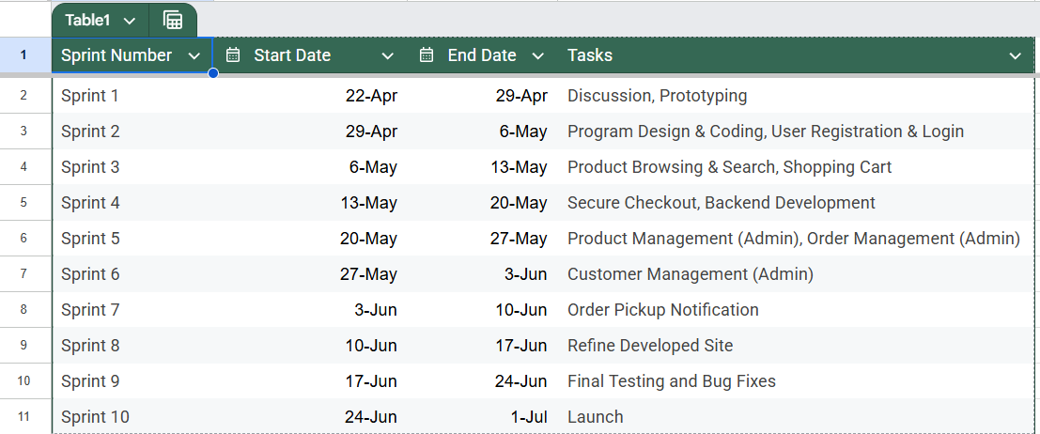

The group has the opportunity to receive some feedback and present a complete functionality to the customers. For example, Final Testing in sprint 9. Besides that, the group also conducted sprint retrospectives to think about what went well and what can be improved. Time management problems will also be observed during the initial sprints and will be addressed to develop more accurate tasks and document project updates.

Each sprint has shown significant progress toward the completed platform and the implementation was smooth throughout the iterations. The team was not stressed by the sprint cycle that allows plenty of time for feature implementation and system testing. Specific roles and regular collaboration has made it necessary to control interactions and solve the issues rapidly.

As a result, the TeeZone project has proceeded without problems due to the development of a straightforward iteration plan that provides measurable outcomes in each sprint which leads to an excellent start during Sprint 10.

# 1.5 Performance Metrics

The group uses performance metrics which is a burnt down chart to measure and evaluate the enhancements of an Agile for the TeeZone project. This will help to monitor the progress, limitations discovering and promote continuous enhancements.

Figure 1.6 Burnt Down Chart from sprint 1 to sprint 10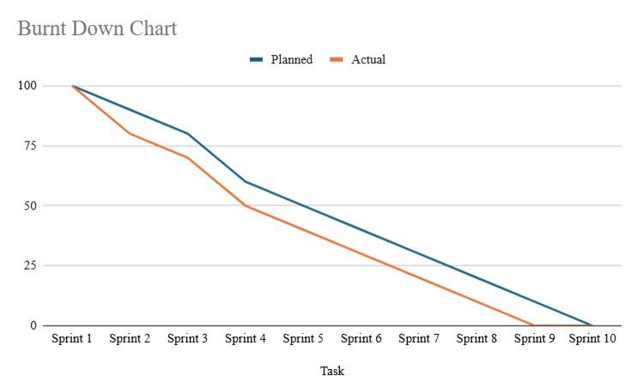

Figure 1.7 shows the burnt down chart that consists of the total amount of work remaining which falls on x-axis against time taken for every 10 sprints which falls on y-axis. There are only 2 lines in this burnt down chart which are planned lines and actual lines. Blue lines represent planned lines and orange lines represent actual lines. The highest achievable progress based on the initial sprint plan is known as planned lines whereas the group real progress throughout every single sprint is known as actual lines.

Initially, the team experienced many challenges especially when it came in sprint 3 because the team was not able to integrate the website payment gateway feature successfully. The orange line will decrease slower than the blue line because of the delay. Therefore, the group will adapt to this situation by improving the collaboration and transferring the responsibilities to the following sprints.

As an example, the group has organized extra meetings through whatsapp to discuss technical difficulties and develop the ideas for solutions. In the following sprints, some of the group members spent an extra amount of time to complete the goals that remained from sprint 3. For sprint 5, everybody has recovered back and achieved what was expected.

The team agile performance is described clearly in this burnt down chart. It illustrates how the group has identified the problems, solved difficulties and worked together to finish the project on time. The team's ability to respond to delays and complete the project on time is proven by the actual progress line with the planned line alignment.

# 1.6 chapter summary

The TeeZone project has guided the development of an online college T-shirt selling system successfully through using the Agile methodology. Strong collaboration and alignment with Agile principles were made possible by the group members by performing the important roles of the Scrum team. Ten weekly sprints were used to arrange iteration planning while every sprint focused on gradual outcomes. Regular stand-ups, sprint reviews and retrospectives were provided as an application guidance. Metrics were also used to evaluate the performance. The outcomes demonstrate a regular improvement and the group ability to modify and recover from mid-project failures. Therefore, the Agile methodology allowed timely delivery, raised team collaboration and led to the launching of a functional and user-focused application.

# Section 3: Evaluation of current technologies applied to the software development

# 3.1 Technology Stack

Figure 3.0 Technology Stack Examples for frontend part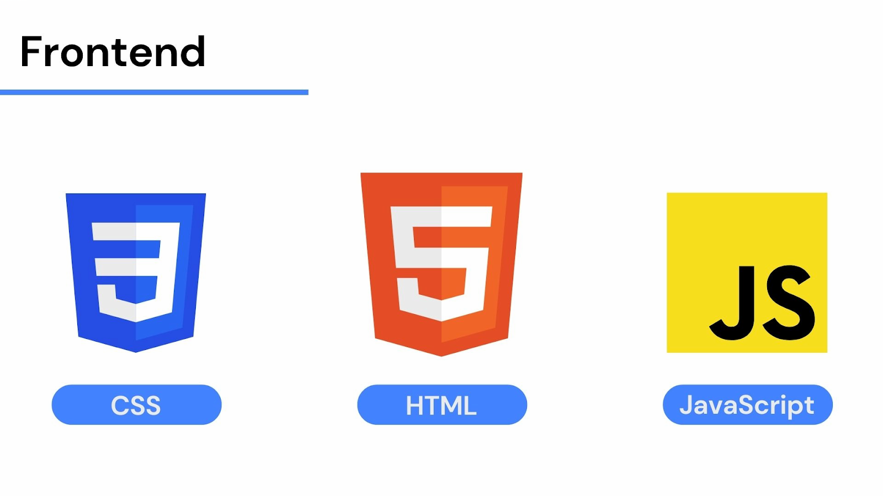

The purpose of this project is to develop a responsive website for selling T-shirts at Inti International College Penang known as TeeZone projects. The group selects HTML, CSS, Javascript and Bootstrap for the front-end part to develop the structure, design and performance of these websites. The content of this website has been determined by HTML known as Hypertext Markup Language that served as the basic structure (MDN Web Docs, 2025). To make sure that the colors, fonts and overall design matched the desired brand identity, CSS stands for Cascading Style Sheets was essential for styling (MDN Web Docs, 2025). Interactive components that consist of product listings and real-time shopping cart updates have become essential via JavaScript (MDN Web Docs, 2025). Additionally, Bootstrap is the framework that is used most commonly worldwide for developing responsive websites (Bootstrap, 2025).

However, PHP known as Hypertext Processor was selected as the server-side programming language for the back-end part. It is suitable for developing interactive e-commerce websites for form submissions, keeping sessions and handling secure user authentication due to its flexibility and easy nature of database integration (The PHP Documentation Group, 2025). Therefore, the group identifies that PHP is the main structure for this project.

On the other hand, SQL stands for Structured Query Language was selected to implement the storage of data to ensure that the user accounts management, order information and product details is secure (AWS, 2025). A user-friendly interface was also given by the usages of PhpMyAdmin as the database administration tools.

# 3.2 Technology Selection Rationale



Figure 3.0 HTML Logo Figure 3.1 CSS Logo Figure 3.2 JavaScript Logo

It was necessary to develop a reliable, secure and user-friendly e-commerce website especially for the college students affected by the software that applied in this project. Due to the popularity and collaboration with browsers like HTML, CSS, JavaScript and Bootstrap have been chosen as the fundamental web technologies of the front-end part (MDN Web Docs, 2025). CSS helped the group to develop an attractive interface that is suitable for the college customers while HTML promotes the logical framework that is necessary for accessibility and the optimization of search engines. JavaScript was also included in the website to make the system more responsive, allowing immediate notifications and interactive product displays for a customer to have an effortless experience.



Figure 3.3 Bootstrap Logo

However, Bootstrap was also selected to speed up the interface design that is responsive and consistent. It reduced the time taken for creating a complete design since this is the framework with pre-build components and best grid arrangement (Bootstrap, 2025). Besides that, it permits fast modifications regarding the customer feedback and increasing the tasks. Therefore, this choice remained in accordance with Agile of delivering usable items regularly.



Figure 3.4 PHP Logo

For the back-end part, PHP was selected due to its efficiency, when developing interactive database-driven websites. For managing the tasks such as form submissions, user authentication and developing an interactive content, PHP server-side scripting skills are important (The PHP Documentation Group, 2025). Producers can manage to fix the issues that support Agile’s goal of open and shared development.



Figure 3.5 SQL Logo Figure 3.6 PhpMyAdmin Logo

On the other hand, SQL was implemented for data management and storage to store and access structured data. The relational database structure can manage the relationship of data in a safe manner. Due to the easy-to-use interface that made it possible for the developers to carry out the activities such as creating tables, running SQL Queries and managing backups, PhpMyAdmin was picked as the database management tools. These tools can enhance the data-related tasks easily while safeguarding the backend safety and discipline.

# 3.3 Integration of Technologies

Figure 3.7 Technologies Integration Diagram for frontend and backend part

Figure 3.7 illustrates the diagram flow for the integration of technologies. It describes the backend PHP that accesses SQL databases through phpMyAdmin for data management and communicates with frontend HTML, CSS, JavaScript and Bootstrap. It combined altogether to produce a single system that maintained an agreement within maintainability, usability and functionality.

The TeeZone project technological structure was carefully planned to provide a reliable interaction between the database, frontend and backend part. First of all, JavaScript has the functionality such as form validation and product display, HTML contains the main content, CSS and Bootstrap ensure that the design is responsive and visually attractive (MDN Web Docs, 2025; Bootstrap, 2025). Therefore, these technologies provide an easy and straightforward online store browsing experience for the customers.

However, PHP controlled the backend part that was used as an interface between the database and the frontend part. The scripts created an interactive content by querying the database and processed incoming requests from the frontend part which are product searches and form submission (The PHP Documentation Group, 2025).

On the other hand, SQL was implemented for data administration and storage and PhpMyAdmin was implemented to access the databases. Every essential data like user accounts, product details and order history has been stored inside the database. PHP and SQL worked altogether but phpMyAdmin presented a useful interface for managing databases and maintenance as PHP applications produced SQL queries to the database to receive the data.

# **References**

1. Sarah Laoyan (2025), What is Agile Methodology? (A Beginner Guide). Retrieved from <https://asana.com/resources/agile-methodology>
2. Design Gurus Team (2025), Why is Scrum called Scrum? Retrieved from <https://www.designgurus.io/answers/detail/why-is-scrum-called-scrum>
3. Beck et al., (2001), Manifesto for Agile Software Development. Retrieved from <https://agilemanifesto.org/>
4. [Scrum.org](http://scrum.org) (2025), What is Scrum? Retrieved from <https://www.scrum.org/learning-series/what-is-scrum/>
5. T2informatik (2025), What is Scrum Master? Retrieved from <https://t2informatik.de/en/smartpedia/scrum-master/>
6. Atlassian (2025), Agile Article. Retrieved from <https://www.atlassian.com/agile/scrum/scrum-master#:~:text=A%20Scrum%20master%20is%20the,team%20to%20improve%20their%20workflows>.
7. Diane Hoffman (2024), What is Product Owner? Retrieved from <https://www.techtarget.com/searchsoftwarequality/definition/product-owner#:~:text=A%20product%20owner%20is%20a,Agile%20principles%20when%20implemented%20effectively>.
8. Madhuri Thakur (2025), Scrum Development Team | Qualities and Responsibilities of Scrum Team. Retrieved from <https://www.educba.com/scrum-development-team/>
9. Ken Schwaber & Jeff Sutherland (2020), Scrum Guide. Retrieved from <https://scrumguides.org/scrum-guide.html>
10. MDN Web Docs (2025), HTML: HyperText Markup Language. Retrieved from <https://developer.mozilla.org/en-US/docs/Web/HTML>
11. MDN Web Docs (2025), CSS: Cascading Style Sheets. Retrieved from <https://developer.mozilla.org/en-US/docs/Web/CSS>
12. MDN Web Docs (2025), javaScript. Retrieved from <https://developer.mozilla.org/en-US/docs/Web/JavaScript>
13. Bootstrap (2025), Introduction. Retrieved from <https://getbootstrap.com/docs/5.0/getting-started/introduction/>
14. The PHP Documentation Group (2025), PHP: Introduction - Manual. Retrieved from <https://www.php.net/manual/en/introduction.php>
15. AWS (2025), What is SQL? - Structured Query Language (SQL) Explained. Retrieved from <https://aws.amazon.com/what-is/sql/>